Computer Networks CL3001 | LAB - 10  Subnetting and RIP
NATIONAL UNIVERSITY OF COMPUTER AND EMERGING SCIENCES, KARACHI CAMPUS
FAST SCHOOL OF COMPUTING (AI & DS, CS, CY, SE)
SPRING 2025

Computer Networks Lab 10

Course: Computer Networks (CL3001) Semester: Spring 2025
Instructor: Muhammad Nadeem T.A: N/A

Note:
- Maintain discipline during the lab.
- Listen and follow the instructions as they are given.
- Just raise hand if you have any problem.
- Completing all tasks of each lab is compulsory.
- Get your lab checked at the end of the session.

Lab Objective
- Introduction to Subnets & Subnetting.
- Purpose of Subnetting.
- Subnet tables of different IPv4 classes.
- Introduction of CIDR.
- Implementation of Subnetting.
- Introduction to Routing protocol & Routed protocol.
- Types of Dynamic Routing & its configuration (RIP).

SUBNETTING
- What is Subnet
A subnet, or subnetwork, is a network inside a network. Subnets make networks more efficient.
Through subnetting, network traffic can travel a shorter distance without passing through unnecessary routers to reach its destination.

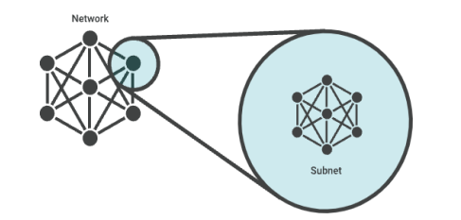
Figure 1
Imagine Imran puts a letter in the mail that is addressed to Asim, who lives in the town right next to his. For the letter to reach Asim as quickly as possible, it should be delivered right from Imran's post office to the post office in Asim's town, and then to Asim. If the letter is first sent to post office hundreds of miles away, Imran's letter could take a lot longer to reach Asim.

Like the postal service, networks are more efficient when messages travel as directly as possible. When a network receives data packets from another network, it will sort and route those packets by subnet so that the packets do not take an inefficient route to their destination.

- What is Subnetting
A subnet is just a range of IP addresses. All the devices in the same subnet can communicate directly with one another without going through any routers. In IPv4, a network interface is connected to only one subnet and has only one IP address. In IPv6 things are slightly more complicated, so we’ll save IPv6 subnetting for another article. But it’s useful to understand IPv4 first because the basic concepts are the same.

My laptop is on a subnet that also includes a server, a printer, a couple of other workstations, and a router. If I want to communicate with another device in my subnet, I can send packets to it directly.
If it’s not on my subnet, I need to forward the packet to a router first. That router also needs to be on my subnet. My computer knows that another device is in my subnet by looking at my own IP address and my subnet mask.

Suppose my IP address is 192.168.101.15 and my subnet mask is 255.255.255.0. There are 32 bits in the IP address and the same number in the mask. We always write those 32 bits as four 8-bit numbers, often called octets. The thing that can make it confusing is that we use decimal notation for each of those 8-bit numbers, but the mechanics of subnetting are really going on in binary.

- Purpose of Subnetting
To subnet a network means to create logical divisions of the network. Subnetting, therefore, involves dividing the network into smaller portions called subnets.
Subnetting applies to IP addresses because this is done by borrowing bits from the host portion of the IP address. In a sense, the IP address then has three components - the network part, the subnet part and, finally, the host part.
We create a subnet by logically grabbing the last bit from the network component of the address and using it to determine the number of subnets required.
In the following example, a Class C address normally has 24 bits for the network address and eight for the host, but we are going to borrow the left- most bit of the host address and declare it as identifying the subnet.

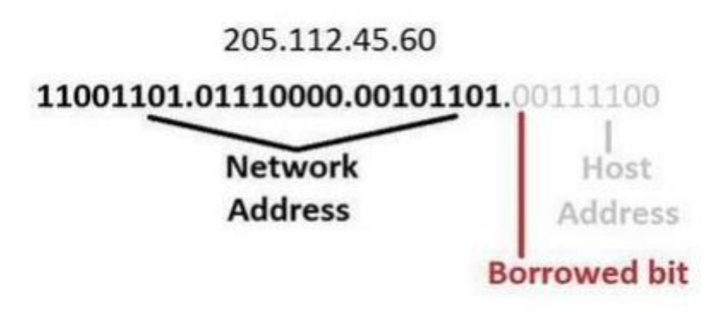
Figure 2
If the bit is a 0, then that will be one subnet; if the bit is a 1 that would be the second subnet.
Of course, with only one borrowed bit we can only have two possible subnets. By the same token, that also reduces the number of hosts we can have on the network to 127 (but actually 125 useable addresses given all zeros and all ones are not recommended addresses), down from 255.

So how can you tell how many bits should be borrowed, or, in other words, how many subnets we want to have on our network? The answer is with a subnet mask.

Subnet masks sound a lot scarier than they really are. All that a subnet mask does is indicate how many bits are being “borrowed” from the host component of an IP address.

If you can’t remember anything about subnetting, remember this concept. It is the foundation of all subnetting. The reason a subnet mask has this name is that it literally masks out the host bits being borrowed from the host address portion of the IP address.
In the following diagram, there is a subnet mask for a Class C address. The subnet mask is 255.255.255.128 which, when translated into bits, indicates which bits of the host part of the address will be used to determine the subnet number.
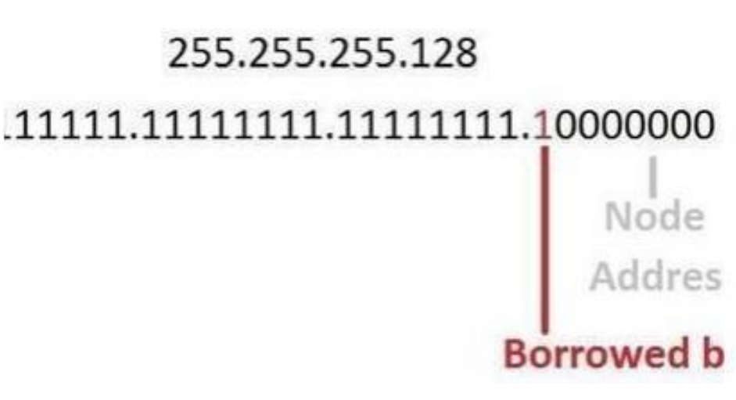
Figure 3
More bits borrowed means fewer individually addressable hosts that can be on the network. Sometimes, all the combinations and permutations can be confusing, so here are some tables of subnet possibilities.

- Subnet Tables of IPV4
In pervious labs we studied the default subnet mask for each class in IPv4.
In this section, we have provided the subnet tables of class A, B & C when we create subnet from these IP address.

Address  Class | Value in First  Octet | Classful Mask  (Dotted Decimal) | Classful Mask  (Prefix Notation)
Class A | 1 - 126 | 255.0.0.0 | /8
Class B | 128 - 191 | 255.255.0.0 | /16
Class C | 192 - 223 | 255.255.255.0 | /24
Class D | 224 - 239 | -- | --
Class E | 240 - 255 | -- | --
Table 1

Class A Host/Subnet Table
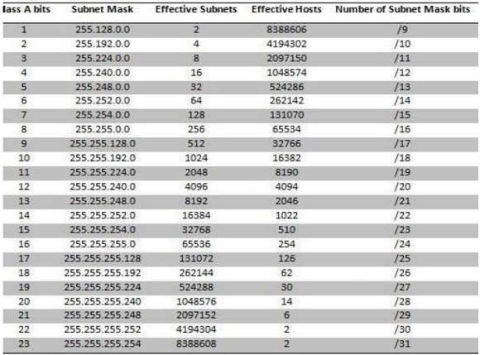
Table 2

Class B Host/Subnet Table
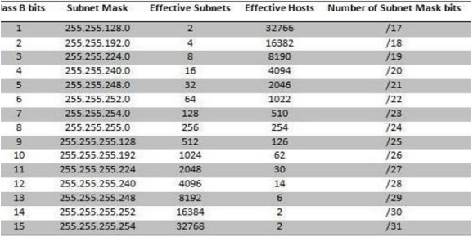
Table 3
Class C Host/Subnet Table
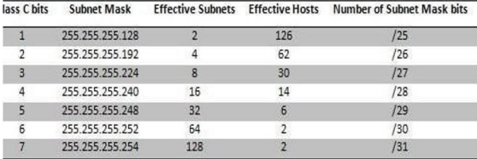
Table 4
- CIDR (Classless Internet Domain Routing)
Having spent a whole bunch of time learning about IP addresses and classes, you might be surprised that in reality they are not used anymore other than to understand the basic concepts of IP addressing.
Instead, network administrators use Classless Internet Domain Routing (CIDR), pronounced "cider", to represent IP addresses.
The idea behind CIDR is to adapt the concept of subnetting to the entire Internet. In short, classless addressing means that instead of breaking a particular network into subnets, we can aggregate networks into larger supernets.

CIDR is therefore often referred to as supernetting, where the principles of subnetting are applied to larger networks. CIDR is written out in a network/mask format, where the mask is tacked onto the network address in the form of the number of bits used in the mask. An example would be 205.112.45.60/25.
What is most important to understand about the CIDR method of subnetting is the use the network prefix (the /25 of 205.112.45.60/25), rather than the classful way of using the first three bits of the IP address to determine the dividing point between the network number and the host number.

The process for understanding what this mean is:
- The “205” in the first octet means this IP address would normally contain 24 bits to represent the network portion of the address. With eight bits to an octet, the arithmetic is 3 x 8 = 24, or looking at it the other way around, “/24” means no bits are being borrowed from the last octet.
- But this is “/25,” which indicates it is “borrowing” one bit from the host portion of the address.
- With only one bit, there can only be two unique subnets.
- So, this is the equivalent of a net mask of 255.255.255.128, where there is a maximum of 126 host addresses addressable on each of the two subnets.

So why did CIDR become so popular? Because it’s a much more efficient allocator of the IP address space.
Using CIDR, a network admin can carve out a number of host addresses that’s closer to what is required than with the class approach.

For example, say a network admin has an IP address of 207.0.64.0/18 to work with. This block consists of 16,384 IP addresses. But if only 900 host addresses are required, this wastes scarce resources, leaving 15,484 (16,384 – 900) addresses unused.
By using a subnet CIDR of 207.0.68.0/22 though, the network would address 1,024 nodes, which is much closer to the 900 host addresses required.

CIDR Address Blocks
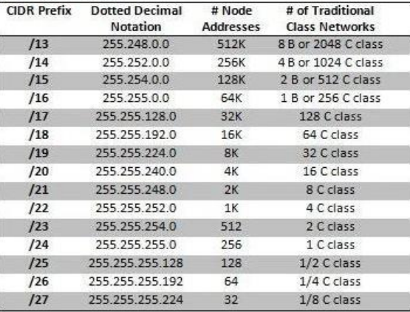
Table 5
- Implementation of Subnetting on Cisco Packet Tracer
Consider an IP of Class C 192.168.1.0/27, using this IP address calculate the subnets and implement the scenario in Cisco Packet Tracer.

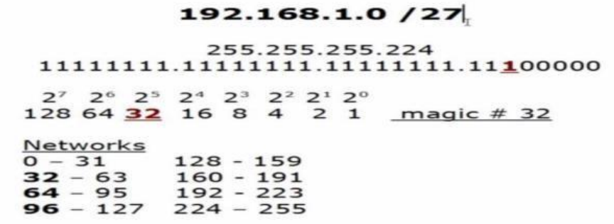
Figure 4
Calculations
From above, we have:
Possible Subnets:2^{n} = 2³ =8
Possible Hosts = 32

The notation "2^{n}" refers to the formula used to calculate the number of possible subnets in a network, where "n" is the number of subnet bits. In this case, you have 2³ (2 raised to the power of 3) because there are 3 subnet bits, which equals 8 possible subnets.
The term "Possible Hosts = 32" indicates the number of hosts that can be accommodated in each subnet. Since there are 5 host bits (2⁵ = 32), each subnet can have up to 32 hosts.

Note: 1st address of every subnet shows network address and last address shows Broadcast address. e.g.,
0,32,64 & 96 represent Network address where 31,63,95 &127 represent Broadcast address.

Custom Subnet Mask = 255.255.255.224

Now let`s implement below topology scenario on Cisco packet Tracer.

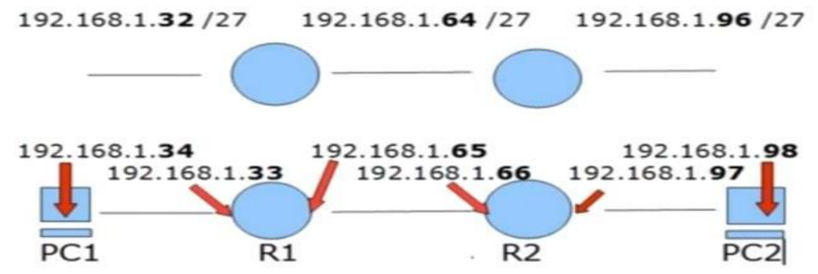
Figure 5
We have taken two routers R1 & R2 and connected their Fast Ethernet interface Fa 0/0 with the switch. While routers connected with their serial interface 2/0.

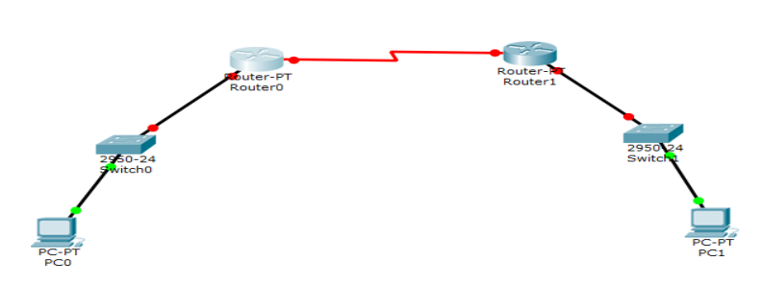
Figure 6
Now configuring PC0:

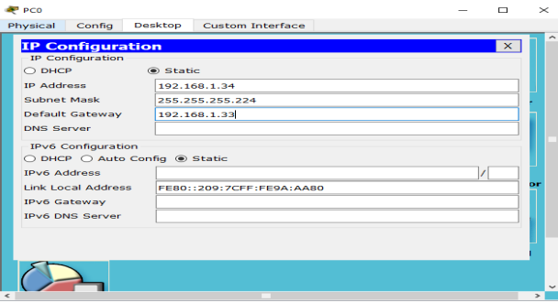
Figure 7
Now configure the Interface FastEthernet0/0 of Router R0:

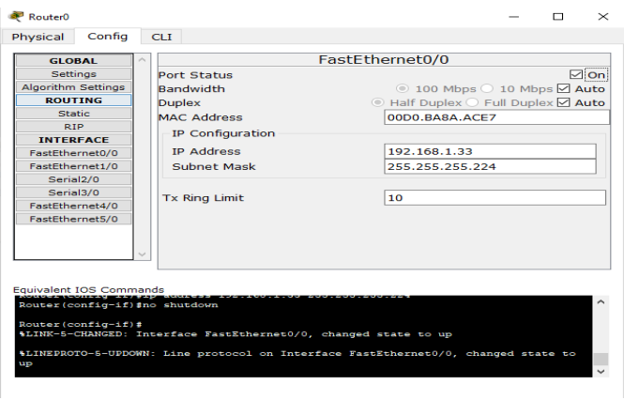
Figure 8
Configure the Interface Serial2/0 of Router R1:

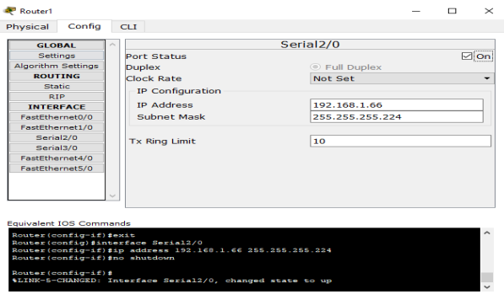
Figure 9
Now configuring PC1:

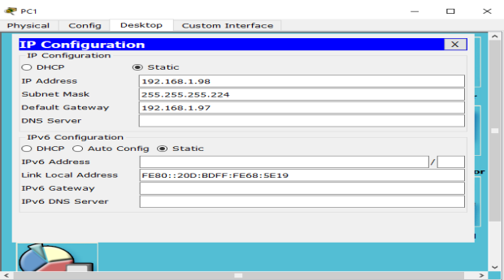
Figure 10
Now we have gone through the entire configuration, all the interfaces are up:
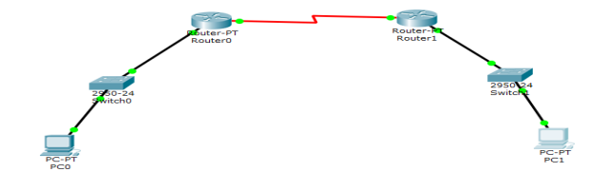
Figure 11
Now let start the pinging the interfaces from PC0.
As we ping 192.168.1.33 and 192.168.1.65, we got the reply because these interfaces are directly connected to Router R0.

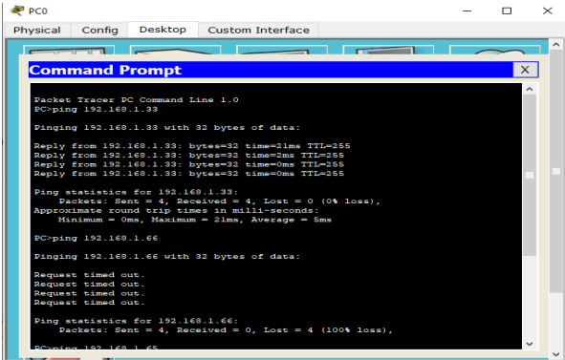
Figure 12
But when we ping 192.168.1.66, we got the Timed out because these interfaces are not directly connected
to Router R1 as shown:
Therefore, we have to add static route in Router R0.
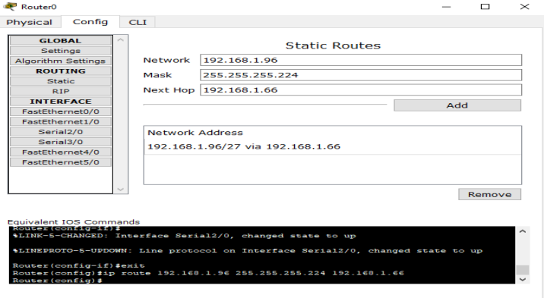
Figure 13

Therefore, we have to add static route in Router R1.

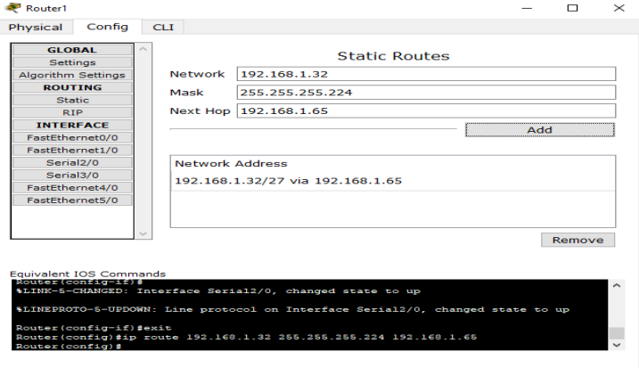
Figure 14
As you can see that we got the reply after adding the static route in Routers R0 & R1:
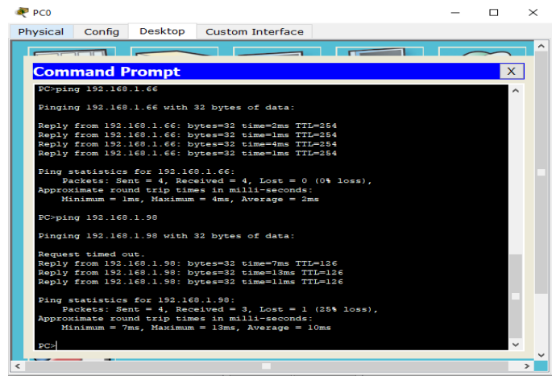
Figure 15

Now using show ip route command we can see all the details of routing table saved in R0:

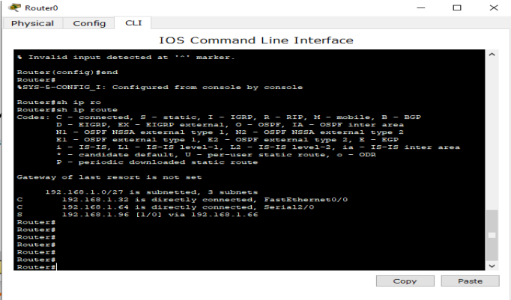
Figure 16
- Introduction to Routing Protocol & Routed Protocol
Routing protocols are like maps that routers use to figure out the best way to send data around a network. There are three main types: distance vector, link state, and path vector. These protocols help routers share information about the network so they can all make smart decisions about where to send data. A routing protocol is used by routers to dynamically find all the networks in the internetwork and to ensure that all routers have the same routing table.

A routed protocol is different. It's like the language used for communication over the network. So, while routing protocols decide which path to take, routed protocols are what actually get sent along those paths.
Routed protocols are assigned to an interface and determine the method of packet delivery.

Examples of routing protocols are RIP, RIPv2, EIGRP, and OSPF.
Examples of routed protocols are IP and IPv6.

- Routing Basis
The term routing is used for taking a packet from one device and sending it through the network to another device on a different network. Routers do not really care about hosts - they only care about networks and the best path to each network.
The logical network address of the destination host is used to get packets to a network through a routed network, and then the hardware address of the host is used to deliver the packet from a router to the correct destination host.

If a network is not directly connected to the router, then the router must use one of two ways to learn how to get to the remote network: static routing, meaning that someone must hand-type all network locations into the routing table, or something called dynamic routing.

- Introduction to Static Routing
Before identifying the benefits of dynamic routing protocols, let`s consider the reasons why network professionals use static routing.
Dynamic routing certainly has several advantages over static routing; however, static routing is still used in networks today. In fact, networks today typically use a combination of both static and dynamic routing.

Static routing has several primary uses, including:
- Providing ease of routing table maintenance in smaller networks that are not expected to grow significantly.
- Routing to and from a stub network, which is a network with only one default route out and no knowledge of any remote networks.
- Accessing a single default route (which is used to represent a path to any network that does not have a more specific match with another route in the routing table).

Consider a simple scenario for static routing:

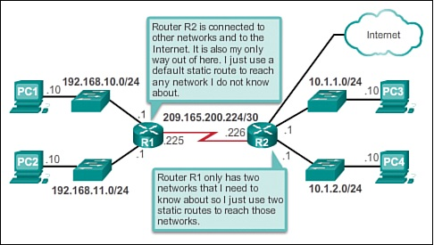
Figure 17

Static routing is easy to implement in a small network. Static routes stay the same, which makes them fairly easy to troubleshoot. Static routes do not send update messages and, therefore, require very little overhead.

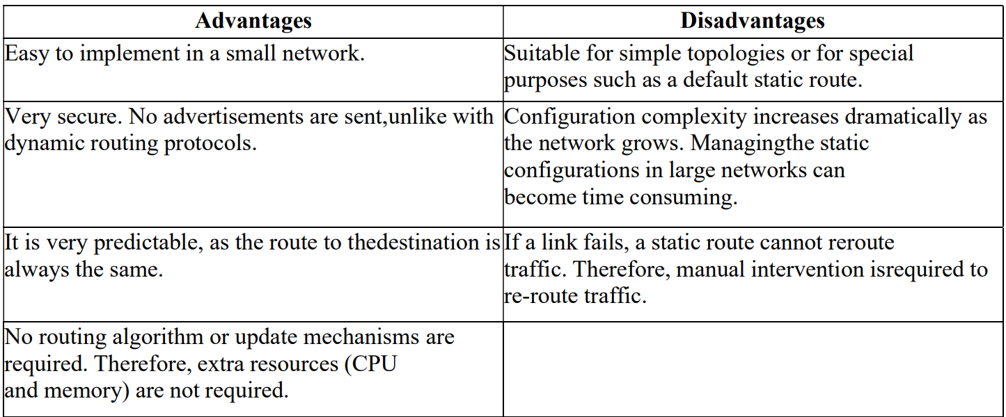

- Default Route
We use default routing to send packets with a remote destination network not in the routing table to the next-hop router. You should only use default routing on stub networks—those with only one exit path out of the network.

- Configuration of Static Route & Default Route
Using Cisco Packet Tracer software, we will now simulate the following network mentioned in the below figure which has 4 networks and 10 subnetworks and assign each host an IP. Also we have to assign an IP for each interface on the router. We assign an IP for the Router interface and start it up using the following commands:

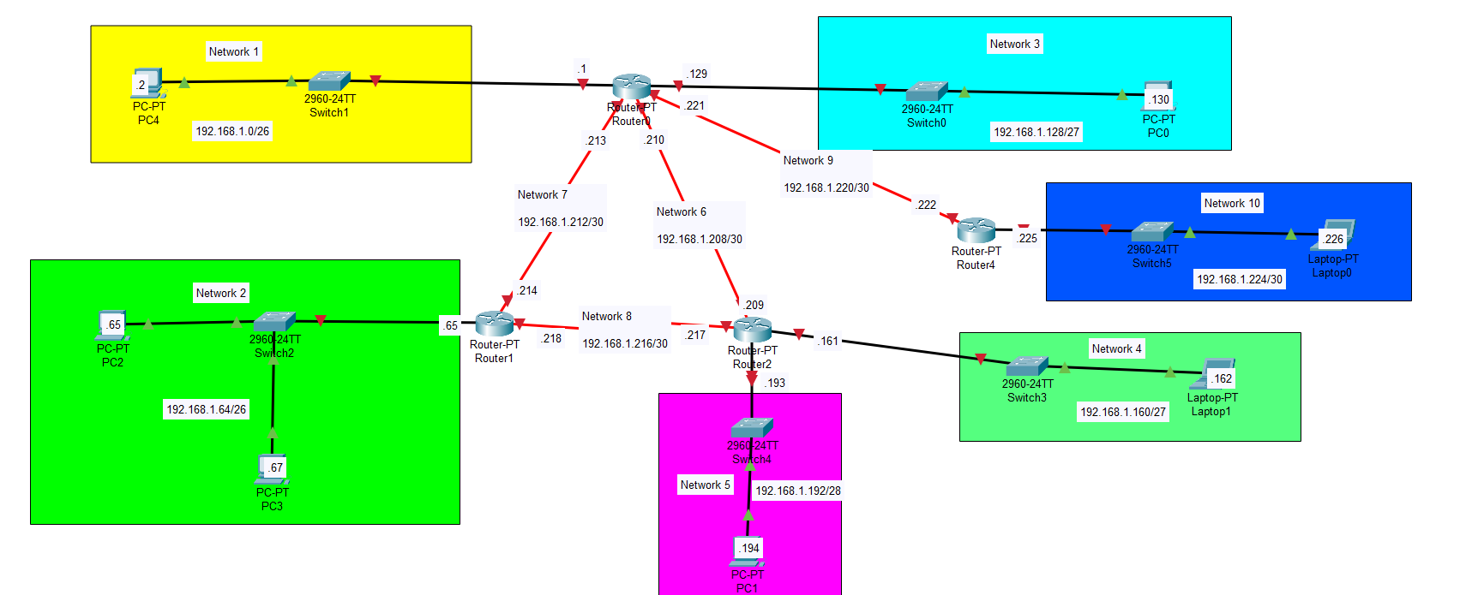
Figure 18

Router(config)#interface fa0/0
Router(config-if)#ip address 192.168.1.129 255.255.255.192
Router(config-if)#no shutdown

Where:
fa0/0: is the name of the interface.
192.168.1.129: is the IP address for interface fa0/0.
255.255.255.192: is the subnet mask being used on the network that connected directly to the interface.
no shutdown: to start up the interface.

Run the same commands for all routers interfaces and assign each interface an appropriate IP/mask pair.
Now we start routing:

Network 10 is connected directly to Router 3 and no other subnets is connected to Router 3, so we can
configure default route on it using the following command:

Router(config)#ip route 0.0.0.0 0.0.0.0 192.168.1.221
Where:
0.0.0.0: is the destination network IP [0.0.0.0 in case of default routing]
0.0.0.0: is the subnet mask being used on the destination network.
192.168.1.221: is the address of the next-hop router that will receive the packet and forward it to the destination network.

For the other routers, we cannot implement default routing since each of them is connected to more than one network. In this case, we use static routing. We can configure static route on router0 as follow:

Router(config)#ip route 192.168.1.64 255.255.255.192 192.168.1.214

Where:
192.168.1.64: is the destination network we want to send packets to it.
255.255.255.192: is the subnet mask being used on the destination network.
192.168.1.214: is the address of the next-hop router that will receive the packet and forward it to the
destination network.

Configuring all other static routes on router0:

Router(config)#ip route 192.168.1.160 255.255.255.224 192.168.1.209
Router(config)#ip route 192.168.1.192 255.255.255.240 192.168.1.209
Router(config)#ip route 192.168.1.224 255.255.255.252 192.168.1.222

Do the same thing for the other routers. To review routing table on a router, use command “show ip route” as shown in the below figure:

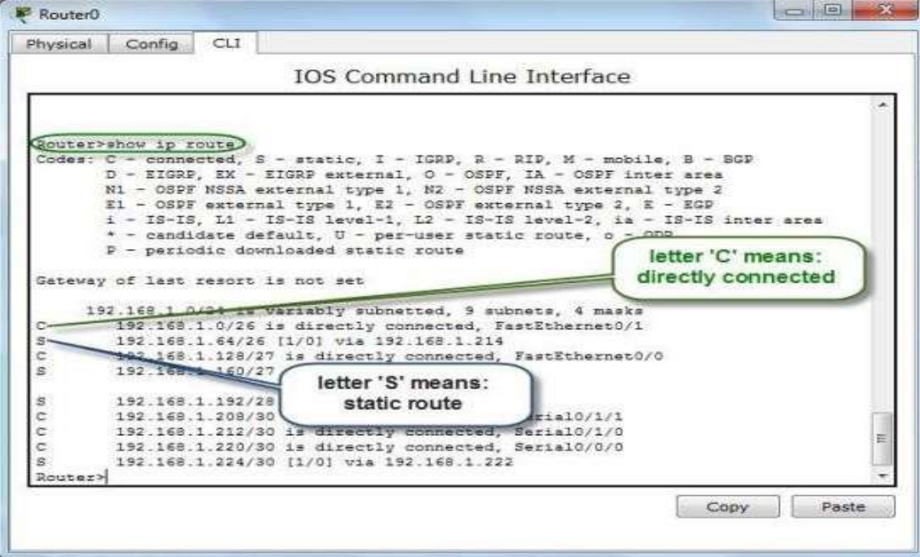
Figure 19
Alternatively, by using the Inspect tool from the right panel, and select “Routing Table” from the menu we can also view the routing table:

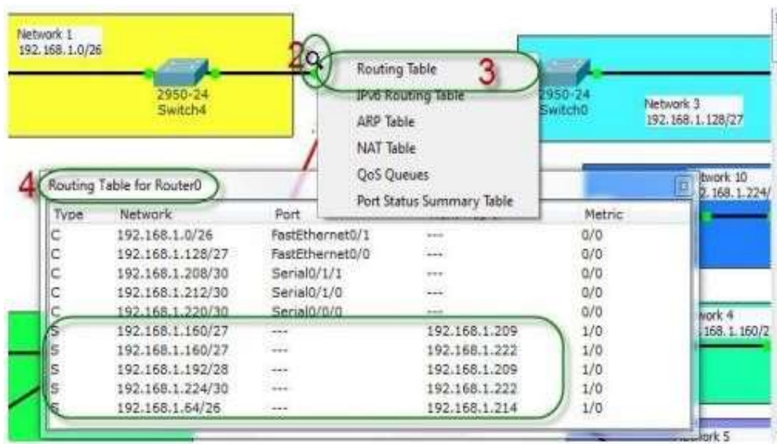
Figure 20
Another quick note: to mention that when (if) the packet is lost on the way back to the originating host, you will typically see a “Request timed out” message because it is an unknown error shown in figure 4. If the error occurs because of a known issue, such as if a route is not in the routing table on the way to the destination device, you will see a “Destination host unreachable” message as shown in the below figure. This should help you determine if the problem occurred on the way to the destination or on the way.

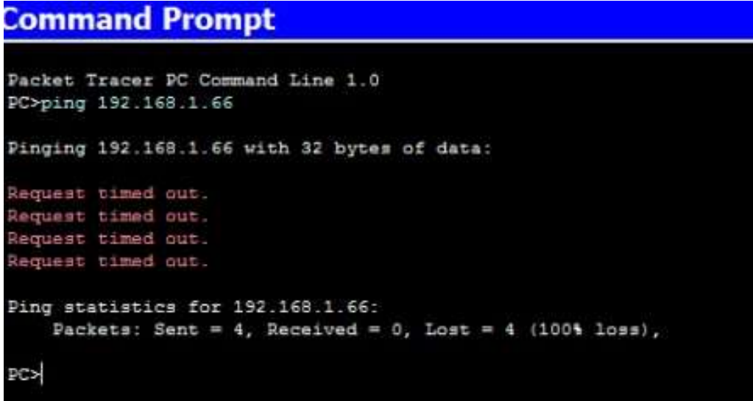
Figure 21
Destination host unreachable message:
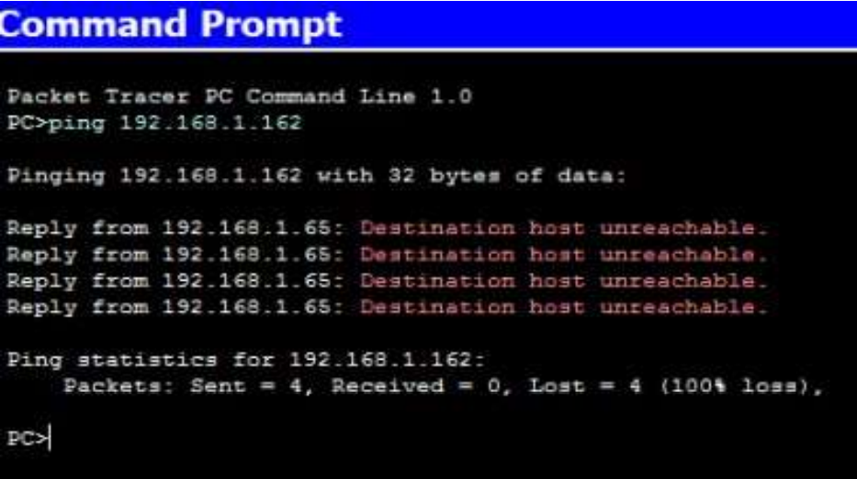
Figure 22
- Administrative Distances
The administrative distance (AD) is used to rate the trustworthiness of routing information received on a router from a neighbor router. An administrative distance is an integer from 0 to 255, where 0 is the most trusted and 255 means no traffic will be passed via this route.

If a router receives two updates listing the same remote network, the first thing the router checks is the AD.
If one of the advertised routes has a lower AD than the other, then the route with the lowest AD will be placed in the routing table. If both advertised routes to the same network have the same AD, then routing protocol metrics (such as hop count or bandwidth of the lines) will be used to find the best path to the remote network. The advertised route with the lowest metric will be placed in the routing table.

But if both advertised routes have the same AD as well as the same metrics, then the routing protocol will load-balance to the remote network (which means that it sends packets down each link).
Table below shows default AD:

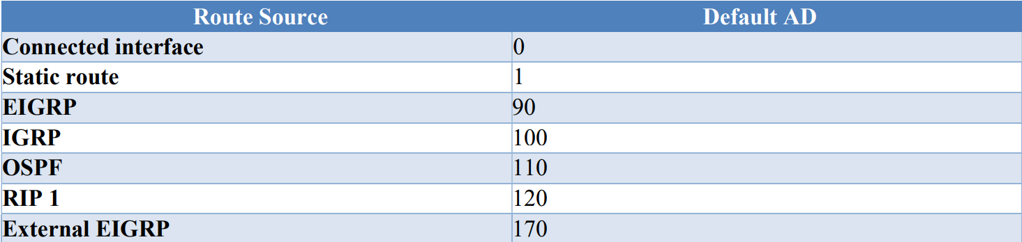
The smaller the AD is, the more preferable to route is.

- Classes of Routing Protocols
Following are the classes of routing protocols:
Distance Vector:
Distance-vector protocols work by counting the number of jumps, or hops, a packet takes through routers to reach its destination network. The route with the fewest hops is considered the best. These protocols, like RIP and IGRP, share their routing information with nearby routers by sending their entire routing table to them.

Link State:
Link-state protocols, also known as shortest-path-first protocols, are smart routers that know a lot about the network. OSPF is an example of this. Instead of just counting hops, they share details about their own connections with all other routers in the network.

Hybrid:
Hybrid protocols use aspects of both distance vector and link state—for example, EIGRP. There’s no set way of configuring routing protocols for use with every business. This is something you really have to do on a case- by-case basis. If you understand how the different routing protocols work, you can make good, solid decisions that truly meet the individual needs of any business.

Path Vector:
Path-vector protocols are designed for routing between autonomous systems (AS) in large-scale networks, such as the internet. Instead of simply counting hops or sharing link-state information, these protocols maintain a path to each destination by recording the sequence of ASes that a route passes through. BGP (Border Gateway Protocol) is the most well-known path-vector protocol, ensuring stable and efficient inter-domain routing by preventing routing loops and optimizing paths based on various attributes.

- Introduction to Dynamic Routing
Dynamic routing is when protocols are used to find networks and update routing tables on routers. This is easier than using static or default routing, but it’ll cost you in terms of router CPU processes and bandwidth on the network links.

A routing protocol defines the set of rules used by a router when it communicates routing information between neighbor routers. The routing protocol includes Routing Information Protocol (RIP) versions 1 and 2, with a bit of Interior Gateway Routing Protocol (IGRP) thrown in.

Two types of routing protocols are used in internetworks: interior gateway protocols (IGPs) and exterior gateway protocols (EGPs).
IGPs are used to exchange routing information with routers in the same autonomous system (AS). An AS is a collection of networks under a common administrative domain, which basically means that all routers sharing the same routing table information are in the same AS.
EGPs are used to communicate between ASes. An example of an EGP is Border Gateway Protocol (BGP).
- Dynamic Routing Types & Their Configuration

Routing Information Protocol (RIP)
Routing Information Protocol (RIP) is a true distance-vector routing protocol. RIP sends the complete routing table out to all active interfaces every 30 seconds. RIP only uses hop count to determine the best way to a remote network, but it has a maximum allowable hop count of 15 by default, meaning that 16 is deemed unreachable. RIP works well in small networks, but it’s inefficient on large networks with slow WAN links or on networks with a large number of routers installed.
Below figure shows a topology with RIP:

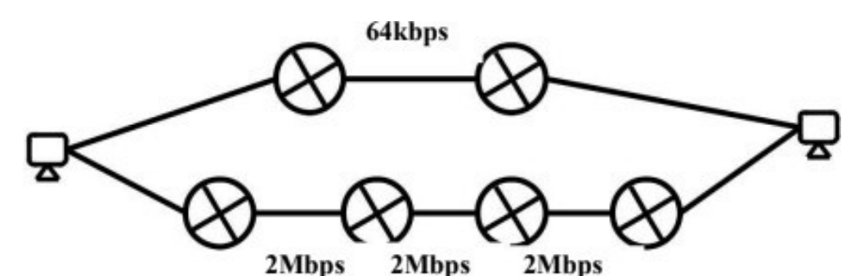
Figure 23
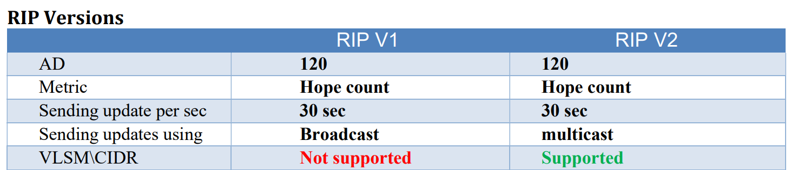

RIP Practical Part

RIP V1
Lab_10#config t Lab_A(config)#router rip
Lab_10(config-router)#network 192.168.10.0 (only net without mask)
Lab_10(config-router)#passive-interface serial 0/0

(The last command prevents RIP update broadcasts from being sent out a specified interface, yet that same interface can still receive RIP updates.)

RIP V2
RIPv2 is considered classless because subnet information is sent with each route update
Lab_10(config)#router rip
Lab_10(config-router)#network 192.168.40.0
Lab_10(config-router)#network 192.168.50.0
Lab_10(config-router)#version 2

Lab Exercises
- Implement the above given example on cisco packet tracer but use network address as10.20.0.0/24 using RIP.

- Let`s consider an example of subnetting for ABC Company. There are 3 departments i.e. Finance, HR and Development.
You have to perform subnetting for the allocation of the given requirement:
120 PCs for Development
35 PCs for Finance
10 PCs for HR

The network address for the given scenario is 200.16.100.0/24. Only show calculation.

- Let`s consider an example of subnetting for FAST NUCES. There are 3 departments i.e. CS, EE and BBA.
You have to perform subnetting for the allocation of the given requirement:
90 PCs for CS
50 PCs for EE
20 PCs for BBA

The network address for the given scenario is 195.168.10.0/24. Implement it on Cisco Packet Tracer and Apply RIPv2.

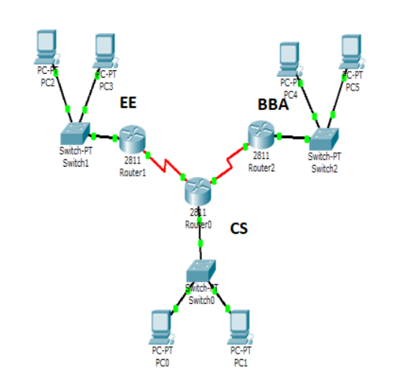
Figure 24

